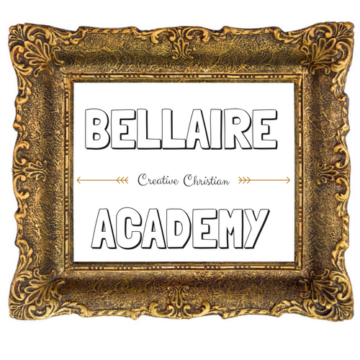
Bellaire Creative Christian Academy
616 Keene Centre Dr
Nicholasville KY, 40356
859-885-4337
www.bellaireacademy.com

Parent Survival Night Registration Form

1.Child’s Full Name:________________________________________________

Date of Birth:_______________________Age:_________________________

2.Child’s Full Name:________________________________________________

Date of Birth:_______________________Age:_________________________

3.Child’s Full Name:________________________________________________

Date of Birth:_______________________Age:_________________________

Address:____________________________________________________________________

Phone:_________________________Email________________________________________

In Case of an emergency while, please indicate an emergency contact person and telephone:
Name:___________________________________________________

Phone:___________________________________________________

Does your child have any allergies? If so, what is the allergy and the severity:

____________________________________________________________________________________

___________________________________________________________________________________

Waiver of Liability, Release, Assumption of Risk & Indemnity Agreement Notice: This is a legally binding agreement. I understand that by signing this Childcare Waiver of Liability, I release and hold harmless Bellaire Creative Christian Academy, and its owners, directors, officers, advisors, employees, agents, instructors, volunteers, childcare workers, and all other persons or entities acting for them from any and all claims, demands, suits, cost and charges, in connection with or arising out of childcare service, including but not limited to, accidental personal injury, bodily harm, injury, or property damage occurring while the above child/children is/are in their care.

* I have read and agree to the terms and conditions.

Applicant’s Signature:______________________________ Date:____________________

Bellaire Creative Christian Academy
616 Keene Centre Dr.
Nicholasville KY, 40356
859-885-4337
www.bellaireacademy.com

Parent Survival Night Terms and Conditions

The price for Parent Survival Night is $25 per child. A sibling discount, applicable only to siblings, is $5 off second child and $10 off third child. PSN is open to all, so friends and neighbors are welcome! Pre-payment and registration is required as space is limited. In the event of not being able to attend, a one week notice is required. Without this notice, any payment is non-refundable or transferrable.

The hours for PSN are 6:30pm-9:30pm. No drop offs are allowed before this time. In the circumstance of a late pick up, a fee of $1 per minute is charged. Parents are encouraged to arrive at least 5 minutes prior to the 9:30 closing time.

Outside items, including food and toys, are not permitted in the center. Please bring in a small cloth bag labeled with a change of clothes in case of need of changing. All children are required to wear socks in the gym. No shoes are allowed on the equipment. Children are welcome to come in pajamas!
PSN is for children ages 2yrs and up. Children must be potty trained or in pull-ups. If your child is in pull-ups, they must arrive freshly changed and with a supply of extra wipes and pull-ups.

General Schedule
Arrival and gym time: 6:30-7:00pm
Pizza and Drinks: 7:00-7:20pm
Craft time offered. Child can choose to participate or continue to use the gym: 7:20-8:00pm
Movie offered. Child can choose to participate or continue to use the gym: 8:00-9:30pm

All staffed personnel have current criminal background checks as well as child abuse and neglect background checks. Staff are also CPR/First Aid certified in the case of an emergency. In the case of a minor accident, first aid will be administered. If there is a more severe accident, parent will be notified immediately.

Code of Conduct

Child’s Name/s: ______________________________________________________________________________________________________________________________________

Parent/Guardian Name: ______________________________
Address: ______________________________ City: ___________________
Cell Phone: ___________________ Work Phone: ___________________

We are here to provide a safe and healthy environment for your child while you enjoy time to yourself. With this in mind,we have outlined some behavior guidelines to ensure the well-being of all.

Expectations
• All children have the responsibility to treat one another, staff and property with respect as age appropriate
• All children have the responsibility to act and behave in a way which does not endanger, intimidate or interfere with the participation of others
• Children have the responsibility to follow the instructions given by staff as age appropriate
• All children have the responsibility to behave according to this code of conduct

Rules – the following forms of behavior are considered a violation of this document and are unacceptable and could result in the immediate termination of services
• Using language which is offensive
• Fighting, bullying or any other forms of aggressive behavior
• Behaving in a manner which is potentially dangerous to self and others

Bellaire Creative Christian Academy reserves the right to suspend or dismiss a child’s participation in activities, without refund of fees, if this code of conduct is breached.

Parent/Guardian Signature: __________________________________________ Date: ______________

